Simple Linear Regression

Birth Weight Dataset / Cow Yield Dataset

Problem Statement
Implement Simple Linear Regression using the following methods:
- Regular Method
– Find b_0, b_1
  - Compute error y bar
  - Plot regression line
- Normal Equations (Least Squares Method)
  - Using direct formulas
  - a_1 fixed
  - a_0 fixed
  - Simultaneous change of a_0, a_1
- Matrix Inversion Method
  - Form matrices
  - Find determinant, adjoint, inverse
  - Solve using A^{-1}B
- Gradient Descent Method
  - Update rule

bnew=bold −α ∂J

j j

  - With stopping Criteria
∂bj

import numpy as np import pandas as pd
import matplotlib.pyplot as plt
from mpl_toolkits.mplot3d import Axes3D
Regular Method

def regular_method(x, y): n = len(x)
x_mean = np.mean(x) y_mean = np.mean(y)

# b1 (slope)
numerator = np.sum((x - x_mean) * (y - y_mean)) denominator = np.sum((x - x_mean) ** 2)
b1 = numerator / denominator

# b0 (intercept)
b0 = y_mean - b1 * x_mean
print(f"Mean of x: {x_mean}") print(f"Mean of y: {y_mean}")
print(f"b0 (intercept): {b0}")
print(f"b1 (slope): {b1}")
y_pred = b0 + b1 * x print(f"y_pred: {y_pred}")
error = y - y_pred print(f"error: {error}")
plt.scatter(x, y, color="blue", label="Actual Data") plt.plot(x, y_pred, color="red", label="Regression Line") plt.xlabel("x")
plt.ylabel("y") plt.title("LinearRegression(Regular Method)") plt.legend()
plt.grid() plt.show()
x = np.array([1, 2, 3, 4, 5])
y = np.array([1, 1, 2, 2, 4]) print(f"Birth Weight Data:")
print(f"x:{x}\ny:{y}") regular_method(x,y)
Birth Weight Data:
x:[1 2 3 4 5]
y:[1 1 2 2 4]
Mean of x: 3.0 Mean of y: 2.0
b0 (intercept): -0.09999999999999964
b1 (slope): 0.7
y_pred: [0.6 1.3 2. 2.7 3.4]
error: [ 0.4 -0.3 0. -0.7 0.6]

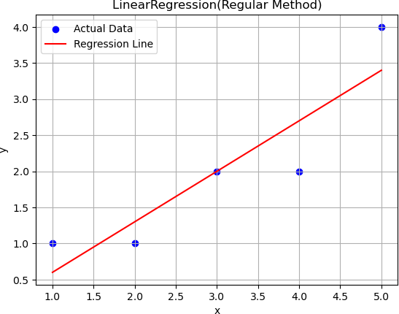
x = np.array([4, 6, 10, 12])
y = np.array([3.0, 5.5, 6.5, 9.0])
print(f"Cow Yield Data:")
print(f"\nx:{x}\ny:{y}\n") regular_method(x,y)
Cow Yield Data:
x:[ 4 6 10 12]
y:[3. 5.5 6.5 9. ]
Mean of x: 8.0 Mean of y: 6.0
b0 (intercept): 0.7999999999999998
b1 (slope): 0.65
y_pred: [3.4 4.7 7.3 8.6]
error: [-0.4 0.8 -0.8 0.4]

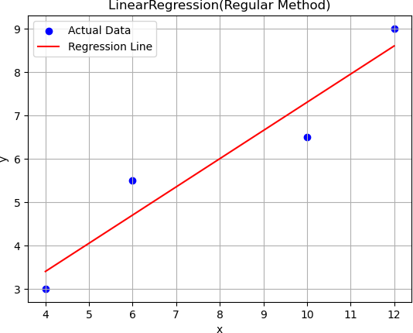
#Birth Weight Data Least Squares Regression Using SSE
x = np.array([1, 2, 3, 4, 5])
y = np.array([1, 1, 2, 2, 4]) n = len(x)
print(f"Birth Weight Data\n") print(f"x = {x}")
print(f"y = {y}") print()
sum_x = np.sum(x) sum_y = np.sum(y) sum_xy = np.sum(x * y)
sum_x2 = np.sum(x ** 2)
print(f"Sum_x = {sum_x}") print(f"Sum_y = {sum_y}") print(f"Sum_xy = {sum_xy}") print(f"Sum_x2 = {sum_x2}") print()
a1 = (n * sum_xy - sum_x * sum_y) / (n * sum_x2 - sum_x ** 2) a0 = (sum_y / n) - a1 * (sum_x / n)

print("a0 (intercept):", a0)
print("a1 (slope):", a1) print()
print(f"y = {a0:.2f} + {a1:.2f}x") print()
y_pred = a0 + a1 * x print(f"y_pred = {y_pred}") print()
error = (y - y_pred) print(f"error = {error}") print()
sse = np.sum((y - y_pred) ** 2) print("Sum of Squared Errors (SSE):", sse)
plt.figure(figsize=(8, 5))
plt.scatter(x, y, color='blue', s=60, label='Actual Data') plt.plot(x, y_pred, color='red', linewidth=2,
label=f'Least Squares (SSE)\n y = {a0:.2f} + {a1:.2f}x')
plt.xlabel('x')
plt.ylabel('y')
plt.title('Least Squares Regression using SSE') plt.legend()
plt.grid(True) plt.show()
Birth Weight Data x = [1 2 3 4 5]
y = [1 1 2 2 4]
Sum_x = 15
Sum_y = 10
Sum_xy = 37
Sum_x2 = 55
a0 (intercept): -0.09999999999999964
a1 (slope): 0.7 y = -0.10 + 0.70x
y_pred = [0.6 1.3 2. 2.7 3.4]
error = [ 0.4 -0.3 0. -0.7 0.6]
Sum of Squared Errors (SSE): 1.0999999999999999

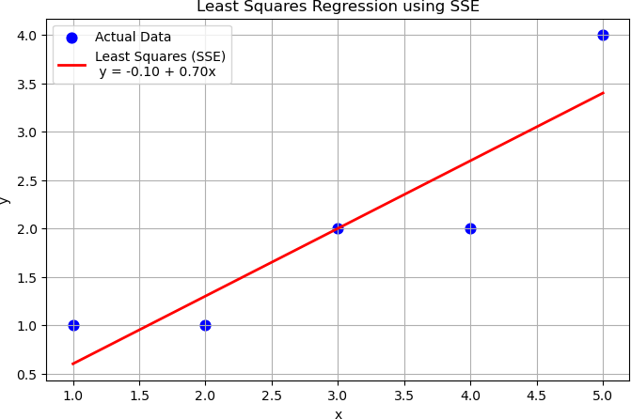
#Cow Yield Data Least Squares Regression Using SSE
x = np.array([4, 6, 10, 12])
y = np.array([3.0, 5.5, 6.5, 9.0])
n = len(x)
print(f"Cow Yield Data\n") print(f"x = {x}")
print(f"y = {y}") print()
sum_x = np.sum(x) sum_y = np.sum(y) sum_xy = np.sum(x * y)
sum_x2 = np.sum(x ** 2)
print(f"Sum_x = {sum_x}") print(f"Sum_y = {sum_y}") print(f"Sum_xy = {sum_xy}") print(f"Sum_x2 = {sum_x2}") print()
a1 = (n * sum_xy - sum_x * sum_y) / (n * sum_x2 - sum_x ** 2) a0 = (sum_y / n) - a1 * (sum_x / n)

print("a0 (intercept):", a0)
print("a1 (slope):", a1) print()
print(f"y = {a0:.2f} + {a1:.2f}x") print()
y_pred = a0 + a1 * x print(f"y_pred = {y_pred}") print()
error = (y - y_pred) print(f"error = {error}") print()
sse = np.sum((y - y_pred) ** 2) print("Sum of Squared Errors (SSE):", sse)
plt.figure(figsize=(8, 5))
plt.scatter(x, y, color='blue', s=60, label='Actual Data') plt.plot(x, y_pred, color='red', linewidth=2,
label=f'Least Squares (SSE)\n y = {a0:.2f} + {a1:.2f}x')
plt.xlabel('x')
plt.ylabel('y')
plt.title('Least Squares Regression using SSE') plt.legend()
plt.grid(True) plt.show()
Cow Yield Data
x = [ 4 6 10 12]
y = [3. 5.5 6.5 9. ]
Sum_x = 32
Sum_y = 24.0
Sum_xy = 218.0
Sum_x2 = 296
a0 (intercept): 0.7999999999999998
a1 (slope): 0.65 y = 0.80 + 0.65x
y_pred = [3.4 4.7 7.3 8.6]
error = [-0.4 0.8 -0.8 0.4]
Sum of Squared Errors (SSE): 1.599999999999998

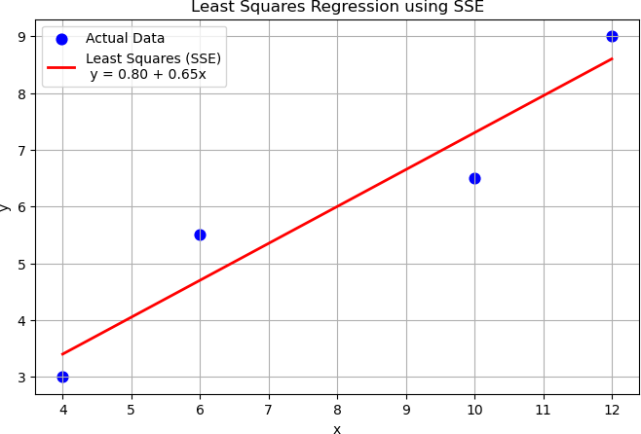
#Birth Weight Data
x = np.array([1, 2, 3, 4, 5])
y = np.array([1, 1, 2, 2, 4]) n = len(x)

# SSE function
def sse(a0, a1):
y_pred = a0 + a1 * x
return np.sum((y - y_pred) ** 2)
a0_vals = np.linspace(-2, 2, 100)
a1_vals = np.linspace(0, 1.5, 100)
A0, A1 = np.meshgrid(a0_vals, a1_vals) SSE = np.zeros_like(A0)
for i in range(len(a0_vals)):
for j in range(len(a1_vals)):
SSE[j, i] = sse(A0[j, i], A1[j, i])

# Least Squares Solution
sum_x = np.sum(x) sum_y = np.sum(y) sum_xy = np.sum(x * y)

sum_x2 = np.sum(x ** 2)
a1_opt = (n * sum_xy - sum_x * sum_y) / (n * sum_x2 - sum_x ** 2) a0_opt = (sum_y / n) - a1_opt * (sum_x / n)

# Contour Plot
plt.figure(figsize=(8, 6))
contours = plt.contour(A0, A1, SSE, levels=20, cmap='viridis') plt.clabel(contours, inline=True, fontsize=8)

# Optimal point
plt.plot(a0_opt, a1_opt, 'ro', label='Minimum SSE')
plt.xlabel('a₀ (Intercept)') plt.ylabel('a₁ (Slope)')
plt.title('Contour Plot of SSE (Least Squares)') plt.legend()
plt.grid(True) plt.show()
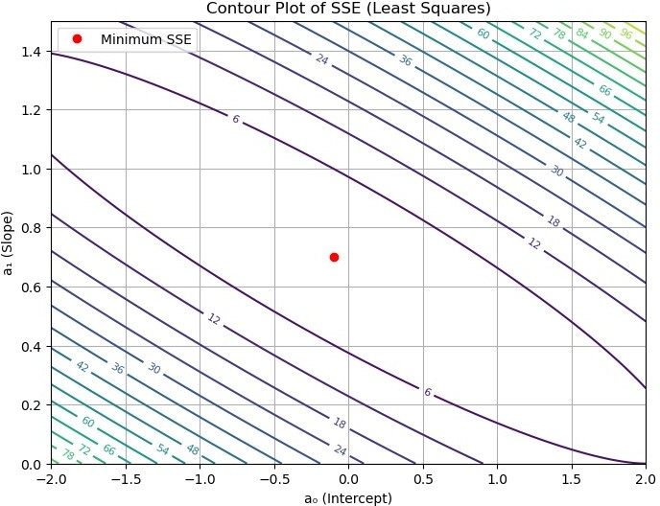

#Cow Yield Data
x = np.array([4, 6, 10, 12])
y = np.array([3.0, 5.5, 6.5, 9.0])
n = len(x)

# SSE function
def sse(a0, a1):
y_pred = a0 + a1 * x
return np.sum((y - y_pred) ** 2)
a0_vals = np.linspace(-2, 2, 100)
a1_vals = np.linspace(0, 1.5, 100)
A0, A1 = np.meshgrid(a0_vals, a1_vals) SSE = np.zeros_like(A0)
for i in range(len(a0_vals)):
for j in range(len(a1_vals)):
SSE[j, i] = sse(A0[j, i], A1[j, i])

# Least Squares Solution
sum_x = np.sum(x) sum_y = np.sum(y) sum_xy = np.sum(x * y)
sum_x2 = np.sum(x ** 2)
a1_opt = (n * sum_xy - sum_x * sum_y) / (n * sum_x2 - sum_x ** 2) a0_opt = (sum_y / n) - a1_opt * (sum_x / n)

# Contour Plot
plt.figure(figsize=(8, 6))
contours = plt.contour(A0, A1, SSE, levels=20, cmap='viridis') plt.clabel(contours, inline=True, fontsize=8)

# Optimal point
plt.plot(a0_opt, a1_opt, 'ro', label='Minimum SSE')
plt.xlabel('a₀ (Intercept)') plt.ylabel('a₁ (Slope)')
plt.title('Contour Plot of SSE (Least Squares)') plt.legend()
plt.grid(True) plt.show()

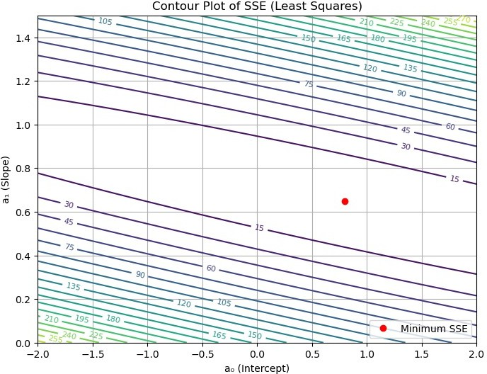
#Birth Weight Data
#S(a0,a1) with fixed and changing
x = np.array([1, 2, 3, 4, 5])
y = np.array([1, 1, 2, 2, 4]) n = len(x)
def sse(a0, a1):
y_hat = a0 + a1 * x
return np.sum((y - y_hat) ** 2)
sum_x = np.sum(x) sum_y = np.sum(y) sum_xy = np.sum(x * y)
sum_x2 = np.sum(x ** 2)
a1_opt = (n * sum_xy - sum_x * sum_y) / (n * sum_x2 - sum_x ** 2) a0_opt = (sum_y / n) - a1_opt * (sum_x / n)
a0_vals = np.linspace(-2, 2, 200)
sse_a0 = [sse(a0, a1_opt) for a0 in a0_vals]

a1_vals = np.linspace(0, 1.5, 200)
sse_a1 = [sse(a0_opt, a1) for a1 in a1_vals] plt.figure(figsize=(12, 5))
plt.subplot(1, 2, 1)
plt.plot(a0_vals, sse_a0, color='purple')
plt.axvline(a0_opt, color='red', linestyle='--', label='Optimal a0') plt.xlabel('a0 (Intercept)')
plt.ylabel('SSE')
plt.title('SSE vs a0 (a1 fixed)') plt.legend()
plt.grid(True)
plt.subplot(1, 2, 2)
plt.plot(a1_vals, sse_a1, color='green')
plt.axvline(a1_opt, color='red', linestyle='--', label='Optimal a1') plt.xlabel('a1 (Slope)')
plt.ylabel('SSE')
plt.title('SSE vs a1 (a0 fixed)') plt.legend()
plt.grid(True)
plt.tight_layout() plt.show()
A0, A1 = np.meshgrid( np.linspace(-2, 2, 200),
np.linspace(0, 1.5, 200)
)
SSE = np.zeros_like(A0)
for i in range(A0.shape[0]):
for j in range(A0.shape[1]):
SSE[i, j] = sse(A0[i, j], A1[i, j])
plt.figure(figsize=(7, 6))
contour = plt.contour(A0, A1, SSE, levels=30, cmap='viridis') plt.clabel(contour, inline=True, fontsize=8)
plt.plot(a0_opt, a1_opt, 'ro', label='Optimal (a0, a1)') plt.xlabel('a0 (Intercept)')
plt.ylabel('a1 (Slope)')
plt.title('SSE Contour Plot (a0 & a1 changing)') plt.legend()
plt.grid(True) plt.show() plt.close()

fig = plt.figure(figsize=(8, 6))
ax = fig.add_subplot(111, projection='3d')
ax.plot_surface(A0, A1, SSE, cmap='viridis', alpha=0.9) ax.scatter(a0_opt, a1_opt, sse(a0_opt, a1_opt),
color='red', s=50, label='Optimal Point')
ax.set_xlabel('a0 (Intercept)') ax.set_ylabel('a1 (Slope)') ax.set_zlabel('SSE')
ax.set_title('SSE Surface (a0 & a1 changing)') ax.legend()
plt.show()
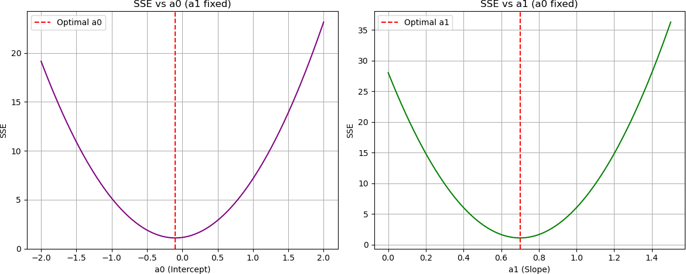

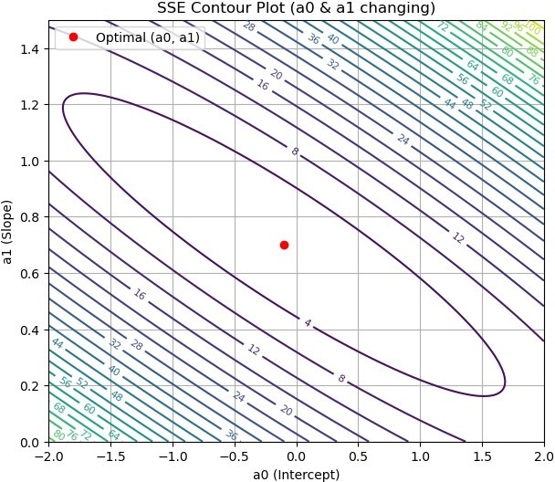

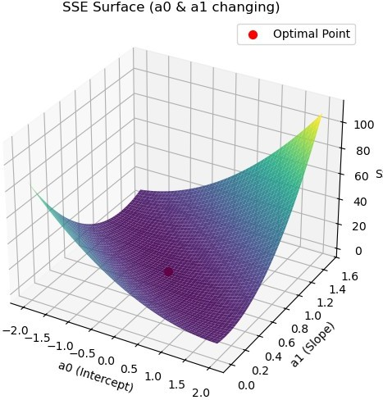
#Cow Yield Data
#S(a0,a1) with fixed and changing
x = np.array([4, 6, 10, 12])
y = np.array([3.0, 5.5, 6.5, 9.0])
def sse(a0, a1):
y_hat = a0 + a1 * x
return np.sum((y - y_hat) ** 2)
sum_x = np.sum(x) sum_y = np.sum(y) sum_xy = np.sum(x * y)
sum_x2 = np.sum(x ** 2)
a1_opt = (n * sum_xy - sum_x * sum_y) / (n * sum_x2 - sum_x ** 2) a0_opt = (sum_y / n) - a1_opt * (sum_x / n)
a0_vals = np.linspace(-2, 2, 200)
sse_a0 = [sse(a0, a1_opt) for a0 in a0_vals]

a1_vals = np.linspace(0, 1.5, 200)
sse_a1 = [sse(a0_opt, a1) for a1 in a1_vals] plt.figure(figsize=(12, 5))
plt.subplot(1, 2, 1)
plt.plot(a0_vals, sse_a0, color='purple')
plt.axvline(a0_opt, color='red', linestyle='--', label='Optimal a0') plt.xlabel('a0 (Intercept)')
plt.ylabel('SSE')
plt.title('SSE vs a0 (a1 fixed)') plt.legend()
plt.grid(True)
plt.subplot(1, 2, 2)
plt.plot(a1_vals, sse_a1, color='green')
plt.axvline(a1_opt, color='red', linestyle='--', label='Optimal a1') plt.xlabel('a1 (Slope)')
plt.ylabel('SSE')
plt.title('SSE vs a1 (a0 fixed)') plt.legend()
plt.grid(True)
plt.tight_layout() plt.show()
A0, A1 = np.meshgrid( np.linspace(-2, 2, 200),
np.linspace(0, 1.5, 200)
)
SSE = np.zeros_like(A0)
for i in range(A0.shape[0]):
for j in range(A0.shape[1]):
SSE[i, j] = sse(A0[i, j], A1[i, j])
plt.figure(figsize=(7, 6))
contour = plt.contour(A0, A1, SSE, levels=30, cmap='viridis') plt.clabel(contour, inline=True, fontsize=8)
plt.plot(a0_opt, a1_opt, 'ro', label='Optimal (a0, a1)') plt.xlabel('a0 (Intercept)')
plt.ylabel('a1 (Slope)')
plt.title('SSE Contour Plot (a0 & a1 changing)') plt.legend()
plt.grid(True) plt.show() plt.close()

fig = plt.figure(figsize=(8, 6))
ax = fig.add_subplot(111, projection='3d')
ax.plot_surface(A0, A1, SSE, cmap='viridis', alpha=0.9) ax.scatter(a0_opt, a1_opt, sse(a0_opt, a1_opt),
color='red', s=50, label='Optimal Point')
ax.set_xlabel('a0 (Intercept)') ax.set_ylabel('a1 (Slope)') ax.set_zlabel('SSE')
ax.set_title('SSE Surface (a0 & a1 changing)') ax.legend()
plt.show()
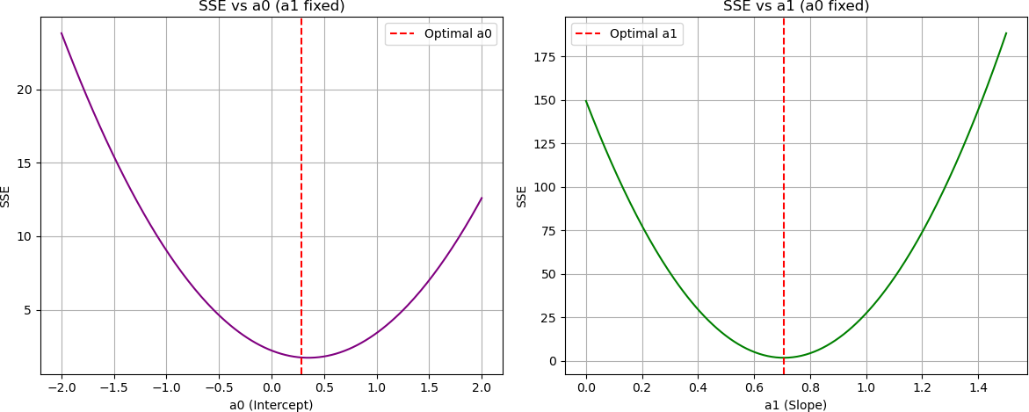

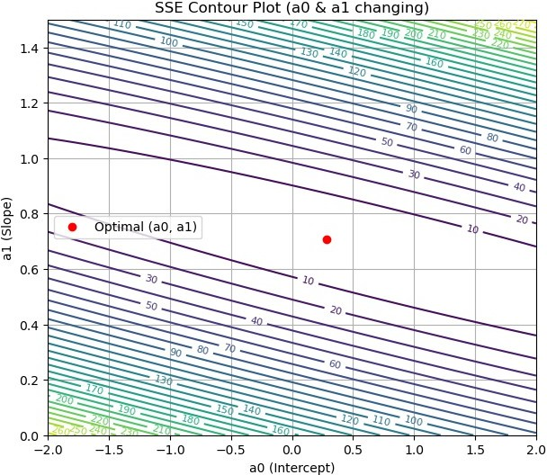

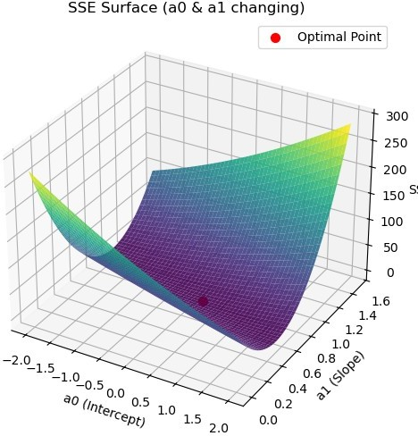
# Birth Weight Data # Matrix Inversion
x = np.array([1, 2, 3, 4, 5])
y = np.array([1, 1, 2, 2, 4])
print(f"x = {x}\ny = {y}\n")
X = np.column_stack((np.ones(len(x)), x)) Y = y.reshape(-1, 1)
print(f"X = \n{X}\nY = \n{Y}\n")

# a = (X^T X)^(-1) X^T y
XT = X.T
print(f"XT = \n{XT}")
a = np.linalg.inv(XT @ X) @ XT @ Y print()
a0 = a[0, 0]
a1 = a[1, 0]
print("a0 (intercept):", a0)

print("a1 (slope):", a1)
y_hat = (X @ a).flatten() print(f"y_pred = {y_hat}") print()
sse = np.sum((y - y_hat) ** 2) print("SSE:", sse)
plt.figure(figsize=(8, 5))
plt.scatter(x, y, color='blue', s=60, label='Actual Data') plt.plot(x, y_hat, color='red', linewidth=2,
label=f'Matrix Method\n y = {a0:.2f} + {a1:.2f}x')
plt.xlabel('x')
plt.ylabel('y')
plt.title('Least Squares Regression (Matrix Inversion)') plt.legend()
plt.grid(True) plt.show()
x = [1 2 3 4 5]
y = [1 1 2 2 4]
X = [[1. 1.]
[1. 2.]
[1. 3.]
[1. 4.]
[1. 5.]] Y =
[[1]
[1]
[2]
[2]
[4]]
XT =
[[1. 1. 1. 1. 1.]
[1. 2. 3. 4. 5.]]
a0 (intercept): -0.0999999999999982
a1 (slope): 0.7000000000000005
y_pred = [0.6 1.3 2. 2.7 3.4]
SSE: 1.0999999999999999

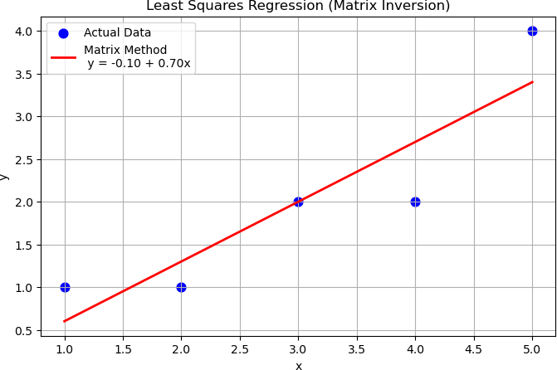
# Birth Weight Data # Matrix Inversion
x = np.array([1, 2, 3, 4, 5])
y = np.array([1, 1, 2, 2, 4])
print(f"x = {x}\ny = {y}\n")
X = np.column_stack((np.ones(len(x)), x)) Y = y.reshape(-1, 1)
print(f"X = \n{X}\nY = \n{Y}\n")

# a = (X^T X)^(-1) X^T y
XT = X.T
print(f"XT = \n{XT}")
a = np.linalg.inv(XT @ X) @ XT @ Y print()
a0 = a[0, 0]
a1 = a[1, 0]
print("a0 (intercept):", a0)
print("a1 (slope):", a1)
y_hat = (X @ a).flatten() print(f"y_pred = {y_hat}")

print()
sse = np.sum((y - y_hat) ** 2) print("SSE:", sse)
plt.figure(figsize=(8, 5))
plt.scatter(x, y, color='blue', s=60, label='Actual Data') plt.plot(x, y_hat, color='red', linewidth=2,
label=f'Matrix Method\n y = {a0:.2f} + {a1:.2f}x')
plt.xlabel('x')
plt.ylabel('y')
plt.title('Least Squares Regression (Matrix Inversion)') plt.legend()
plt.grid(True) plt.show()
x = [1 2 3 4 5]
y = [1 1 2 2 4]
X = [[1. 1.]
[1. 2.]
[1. 3.]
[1. 4.]
[1. 5.]] Y =
[[1]
[1]
[2]
[2]
[4]]
XT =
[[1. 1. 1. 1. 1.]
[1. 2. 3. 4. 5.]]
a0 (intercept): -0.0999999999999982
a1 (slope): 0.7000000000000005
y_pred = [0.6 1.3 2. 2.7 3.4]
SSE: 1.0999999999999999


# Cow Yield Data
# Matrix Inversion
x = np.array([4, 6, 10, 12])
y = np.array([3.0, 5.5, 6.5, 9.0])
print(f"x = {x}\ny = {y}\n")
X = np.column_stack((np.ones(len(x)), x)) Y = y.reshape(-1, 1)
print(f"X = \n{X}\nY = \n{Y}\n")

# a = (X^T X)^(-1) X^T y
XT = X.T
print(f"XT = \n{XT}")
a = np.linalg.inv(XT @ X) @ XT @ Y print()
a0 = a[0, 0]
a1 = a[1, 0]
print("a0 (intercept):", a0)
print("a1 (slope):", a1)
y_hat = (X @ a).flatten() print(f"y_pred = {y_hat}")

print()
sse = np.sum((y - y_hat) ** 2) print("SSE:", sse)
plt.figure(figsize=(8, 5))
plt.scatter(x, y, color='blue', s=60, label='Actual Data') plt.plot(x, y_hat, color='red', linewidth=2,
label=f'Matrix Method\n y = {a0:.2f} + {a1:.2f}x')
plt.xlabel('x')
plt.ylabel('y')
plt.title('Least Squares Regression (Matrix Inversion)') plt.legend()
plt.grid(True) plt.show()
x = [ 4 6 10 12]
y = [3. 5.5 6.5 9. ]
X =
[[ 1. 4.]
[ 1. 6.]
[ 1. 10.]
[ 1. 12.]] Y =
[[3. ]
[5.5]
[6.5]
[9. ]]
XT =
[[ 1. 1. 1. 1.]
[ 4. 6. 10. 12.]]
a0 (intercept): 0.7999999999999972
a1 (slope): 0.6500000000000004
y_pred = [3.4 4.7 7.3 8.6]
SSE: 1.6

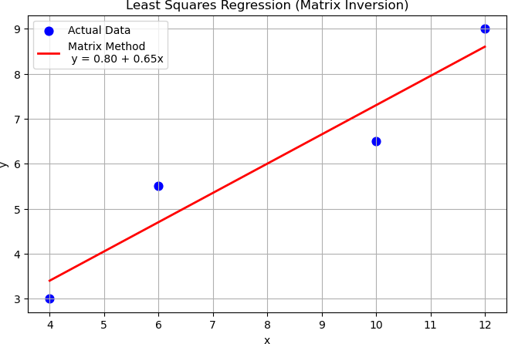
#Birth Weight Data #Gradient Descent
x = np.array([1, 2, 3, 4, 5])
y = np.array([1, 1, 2, 2, 4]) n = len(x)
b0 = 0.0
b1 = 0.0
alpha = 0.01
epochs = 1000 cost_history = []
# Gradient Descent
for _ in range(epochs): y_hat = b0 + b1 * x error = y - y_hat
db0 = -2/n * np.sum(error)
db1 = -2/n * np.sum(error * x)
b0 = b0 - alpha * db0 b1 = b1 - alpha * db1

cost = np.sum(error ** 2) cost_history.append(cost)
print("Final b0:", b0) print("Final b1:", b1)
y_hat = b0 + b1 * x plt.figure(figsize=(12, 5))
plt.subplot(1, 2, 1)
plt.scatter(x, y, color='blue', label='Actual Data') plt.plot(x, y_hat, color='red', label='Gradient Descent Fit') plt.xlabel('x')
plt.ylabel('y')
plt.title('Linear Regression (Gradient Descent)') plt.legend()
plt.grid(True)
plt.subplot(1, 2, 2) plt.plot(cost_history, color='purple') plt.xlabel('Iteration') plt.ylabel('SSE')
plt.title('SSE Decrease during Gradient Descent') plt.grid(True)
plt.tight_layout() plt.show()
Final b0: -0.0907687781409501
Final b1: 0.6974430995681616
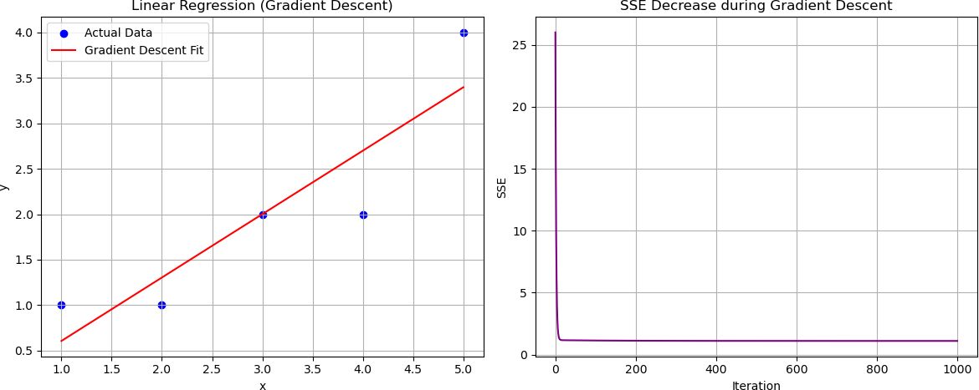
#Cow Yield Data #Gradient Descent

x = np.array([4, 6, 10, 12])
y = np.array([3.0, 5.5, 6.5, 9.0])
n = len(x)
b0 = 0.0
b1 = 0.0
alpha = 0.01
epochs = 1000 cost_history = []
# Gradient Descent
for _ in range(epochs): y_hat = b0 + b1 * x error = y - y_hat
db0 = -2/n * np.sum(error)
db1 = -2/n * np.sum(error * x)
b0 = b0 - alpha * db0 b1 = b1 - alpha * db1
cost = np.sum(error ** 2) cost_history.append(cost)
print("Final b0:", b0) print("Final b1:", b1)
y_hat = b0 + b1 * x plt.figure(figsize=(12, 5))
plt.subplot(1, 2, 1)
plt.scatter(x, y, color='blue', label='Actual Data') plt.plot(x, y_hat, color='red', label='Gradient Descent Fit') plt.xlabel('x')
plt.ylabel('y')
plt.title('Linear Regression (Gradient Descent)') plt.legend()
plt.grid(True)
plt.subplot(1, 2, 2) plt.plot(cost_history, color='purple') plt.xlabel('Iteration') plt.ylabel('SSE')
plt.title('SSE Decrease during Gradient Descent') plt.grid(True)
plt.tight_layout() plt.show()

Final b0: 0.7503082106031975
Final b1: 0.6553817995769352
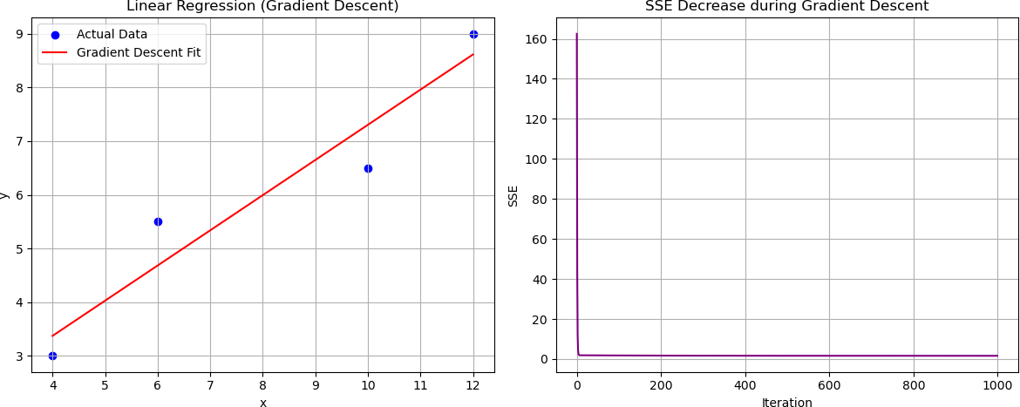

Multiple Linear Regression

Birth Weight Dataset / Cow Yield Dataset

Problem Statement
Implement Multiple Linear Regression using the following methods. We consider a dataset with multiple independent variables:
X =[ x1 , x2 , x3 ,…, xn ) , y=dependent variable
The hypothesis function is:
^y=b0 +b1 x1+ b2 x2 +⋯+bn xn

Regular Method (Direct Computation)

Steps
  - Assume the linear model:
^y=b0 +b1 x1+ b2 x2 +⋯+bn xn
- Estimate coefficients

manually or iteratively.
- Compute predicted values:
b0 , b1 ,…, bn

- Compute error:
n
^yi=b0 +∑ b j xi j
j=1

ei= yi − ^yi

- Evaluate model performance using:
  - Mean Squared Error (MSE)
  - Root Mean Squared Error (RMSE)

Normal Equations (Least Squares Method)

Model Representation
y= X b
Where:
- $ X $ is the design matrix with a column of ones

- $ b $ is the parameter vector

Normal Equation
b=( X^{T} X )−1 X^{T} y

Cases
- Fixed coefficients $ b_0, b_1, \dots, b_n $
- Simultaneous optimization of all parameters

Matrix Inversion Method

Step 1: Form the Matrices
1 x11 x12 ⋯ x1 n
[ )
X = 1 x21 x22 ⋯ x2 n xm1 ¿ xm 2 ¿⋯¿ xmn ¿
¿ ¿

y= y2 )
y_{m}
[y1

Step 2: Compute
- Determinant of $ X^T X $

- Adjoint of $ X^T X $

- Inverse $ (X^T X)^{-1} $

Step 3: Solve Parameters
b=( X^{T} X )−1 X^{T} y

Gradient Descent Method

Cost Function
1 ^{m} 2

Partial Derivative
J (b)= ∑( y^i − yi )
i=1
2 m

∂J 1 ^{m}
∂b = m ∑( ^yi − yi ) xi j

Update Rule
j i=1

bnew=bold −α ∂J
j j ∂b
j

Where:
- $ \alpha $ = learning rate

- $ j = 0, 1, 2, \dots , n $

Algorithm
  - Initialize parameters $ b_0, b_1, \dots, b_n $
  - Repeat until convergence:
    - Compute predictions
    - Compute gradients

    - Update parameters
  - Plot Cost vs Iterations

import numpy as np
import matplotlib.pyplot as plt
from mpl_toolkits.mplot3d import Axes3D
from sklearn.linear_model import SGDRegressor from sklearn.metrics import mean_squared_error
#Direct Method
x1 = np.array([8, 11, 9, 6, 6], dtype=float)
x2 = np.array([12, 6, 6, 3, 18], dtype=float)
y = np.array([0.6, 1.2, 1.0, 0.7, 0.3], dtype=float)
X = np.column_stack((np.ones(len(x1)), x1, x2)) print(f"X=\n{X}\n")
B = np.linalg.inv(X.T @ X) @ X.T @ y print(f"B={B}\n")
b0, b1, b2 = B
print("Regression Coefficients:") print("b0 =", b0)
print("b1 =", b1)
print("b2 =", b2)
y_pred = X @ B
print("\nPredicted values:", y_pred)
errors = y - y_pred print("errors:", errors) MSE = np.mean(errors ** 2) RMSE = np.sqrt(MSE)
print("\nMean Squared Error (MSE):", MSE) print("Root Mean Squared Error (RMSE):", RMSE)
fig = plt.figure()
ax = fig.add_subplot(111, projection='3d') ax.scatter(x1, x2, y, label="Actual Data")
x1_range = np.linspace(min(x1), max(x1), 10) x2_range = np.linspace(min(x2), max(x2), 10) x1_grid, x2_grid = np.meshgrid(x1_range, x2_range)
y_grid = b0 + b1 * x1_grid + b2 * x2_grid

ax.plot_surface(x1_grid, x2_grid, y_grid, alpha=0.5)
ax.set_xlabel("x1") ax.set_ylabel("x2") ax.set_zlabel("y")
ax.set_title("Multiple Linear Regression") plt.show()
X=

[ 1. 6. 18.]]
B=[ 0.10365079 0.11507937 -0.02936508]
Regression Coefficients:
b0 = 0.10365079365079133
b1 = 0.11507936507936496
b2 = -0.029365079365079393
Predicted values: [0.67190476 1.19333333 0.9631746 0.70603175
0.26555556]
errors: [-0.07190476 0.00666667 0.0368254 -0.00603175 0.03444444]
Mean Squared Error (MSE): 0.0015587301587301555 Root Mean Squared Error (RMSE): 0.03948075681556973
[[ 1. 8. 12.]
[ 1. 11. 6.]
[ 1. 9. 6.]
[ 1. 6. 3.]

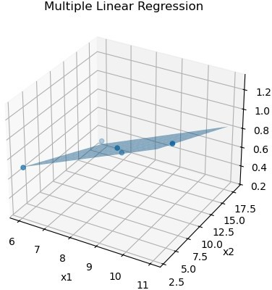
# Normal Equations ( Least Squares Method)
x1 = np.array([8, 11, 9, 6, 6], dtype=float)
x2 = np.array([12, 6, 6, 3, 18], dtype=float)
y = np.array([0.6, 1.2, 1.0, 0.7, 0.3], dtype=float)
X = np.column_stack((np.ones(len(x1)), x1, x2)) print(f"X = \n{X}\n")
XT = X.T
print(f"XT = \n{XT}\n")
B = np.linalg.inv(XT @ X) @ XT @ y print(f"B = {B}\n")
b0, b1, b2 = B
print("Coefficients using Normal Equations:") print("b0 =", b0)
print("b1 =", b1)
print("b2 =", b2)
y_pred = X @ B print("\nPredicted y values:") print(y_pred)

errors = y - y_pred
MSE = np.mean(errors ** 2) RMSE = np.sqrt(MSE)
print("\nMean Squared Error (MSE):", MSE) print("Root Mean Squared Error (RMSE):", RMSE)
fig = plt.figure()
ax = fig.add_subplot(111, projection='3d')
ax.scatter(x1, x2, y, label="Actual Data")
x1_range = np.linspace(min(x1), max(x1), 10) x2_range = np.linspace(min(x2), max(x2), 10) x1_grid, x2_grid = np.meshgrid(x1_range, x2_range)
y_grid = b0 + b1 * x1_grid + b2 * x2_grid ax.plot_surface(x1_grid, x2_grid, y_grid, alpha=0.5)
ax.set_xlabel("x1") ax.set_ylabel("x2") ax.set_zlabel("y")
ax.set_title("Multiple Linear Regression Plane") plt.show()
X =
[[ 1. 8. 12.]
[ 1. 11. 6.]
[ 1. 9. 6.]
[ 1. 6. 3.]
[ 1. 6. 18.]]

XT =
[[ 1. 1. | 1. | 1. | 1.]
[ 8. 11. | 9. | 6. | 6.]
[12. 6. 6. 3. 18.]]
B = [ 0.10365079 0.11507937 -0.02936508]
Coefficients using Normal Equations:
b0 = 0.10365079365079133
b1 = 0.11507936507936496
b2 = -0.029365079365079393
Predicted y values:
[0.67190476 1.19333333 0.9631746 0.70603175 0.26555556]

Mean Squared Error (MSE): 0.0015587301587301555 Root Mean Squared Error (RMSE): 0.03948075681556973
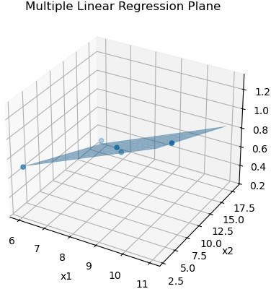
# Direct Method using Libraries
x1 = np.array([8, 11, 9, 6, 6])
x2 = np.array([12, 6, 6, 3, 18])
y = np.array([0.6, 1.2, 1.0, 0.7, 0.3])
X = np.column_stack((x1, x2))
model = SGDRegressor( learning_rate='constant', eta0=0.01,
max_iter=1, tol=None, warm_start=True
)
iterations = 200 losses = []
for i in range(iterations): model.partial_fit(X, y) y_pred = model.predict(X)
mse = mean_squared_error(y, y_pred)

losses.append(mse)
b0 = model.intercept_[0] b1, b2 = model.coef_
print("Regression Coefficients:") print("b0 =", b0)
print("b1 =", b1)
print("b2 =", b2)
y_pred = model.predict(X) errors = y - y_pred
print("\nPredicted values:", y_pred) print("Errors:", errors)
MSE = mean_squared_error(y, y_pred) RMSE = np.sqrt(MSE)
print("\nMean Squared Error (MSE):", MSE) print("Root Mean Squared Error (RMSE):", RMSE)
fig = plt.figure()
ax = fig.add_subplot(111, projection='3d') ax.scatter(x1, x2, y)
x1_range = np.linspace(min(x1), max(x1), 10) x2_range = np.linspace(min(x2), max(x2), 10) x1_grid, x2_grid = np.meshgrid(x1_range, x2_range)
y_grid = b0 + b1 * x1_grid + b2 * x2_grid ax.plot_surface(x1_grid, x2_grid, y_grid, alpha=0.5)
ax.set_xlabel("x1") ax.set_ylabel("x2") ax.set_zlabel("y")
ax.set_title("Multiple Linear Regression (SGD)")
plt.show() plt.close() print()
plt.figure()
plt.plot(range(1, iterations + 1), losses) plt.xlabel("Iterations")
plt.ylabel("Mean Squared Error (Loss)") plt.title("Loss vs Iterations (Regular Method)") plt.show()

Regression Coefficients:
b0 = 0.01733428283737028
b1 = 0.11440946195588057
b2 = -0.05309447600416268
Predicted values: [ 0.29547627 0.95727151 0.72845258 0.54450763 -
0.25190951]
Errors: [0.30452373 0.24272849 0.27154742 0.15549237 0.55190951]
Mean Squared Error (MSE): 0.11083436263549888
Root Mean Squared Error (RMSE): 0.33291795180719663
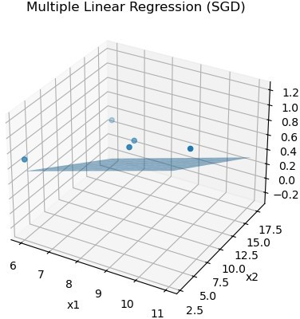

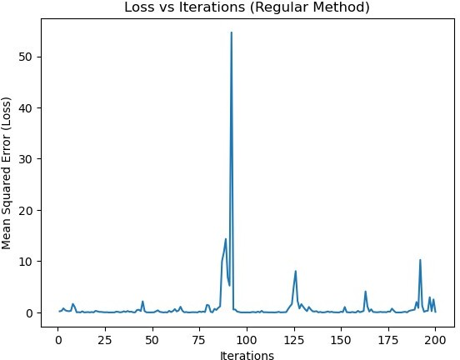
# Matrix Inversion Method
x1 = np.array([8, 11, 9, 6, 6], dtype=float)
x2 = np.array([12, 6, 6, 3, 18], dtype=float)
y = np.array([0.6, 1.2, 1.0, 0.7, 0.3], dtype=float)
X = np.column_stack((np.ones(len(x1)), x1, x2)) print("X =\n", X, "\n")
XT = X.T
XTX = XT @ X
print("XᵀX =\n", XTX, "\n")
det_XTX = np.linalg.det(XTX) print("Determinant of XᵀX =", det_XTX, "\n")
adj_XTX = np.linalg.inv(XTX) * det_XTX print("Adjoint of XᵀX =\n", adj_XTX, "\n")
inv_XTX = np.linalg.inv(XTX) print("Inverse of XᵀX =\n", inv_XTX, "\n")
B = inv_XTX @ XT @ y
print("Regression Coefficients Vector B =", B, "\n")

b0, b1, b2 = B
print("Final Coefficients:") print("b0 =", b0)
print("b1 =", b1)
print("b2 =", b2)
y_pred = X @ B
print("\nPredicted values:", y_pred)
errors = y - y_pred
MSE = np.mean(errors**2) RMSE = np.sqrt(MSE)
print("\nMean Squared Error (MSE):", MSE) print("Root Mean Squared Error (RMSE):", RMSE)
fig = plt.figure()
ax = fig.add_subplot(111, projection='3d') ax.scatter(x1, x2, y)
x1_range = np.linspace(min(x1), max(x1), 10) x2_range = np.linspace(min(x2), max(x2), 10) x1_grid, x2_grid = np.meshgrid(x1_range, x2_range)
y_grid = b0 + b1 * x1_grid + b2 * x2_grid ax.plot_surface(x1_grid, x2_grid, y_grid, alpha=0.5)
ax.set_xlabel("x1") ax.set_ylabel("x2") ax.set_zlabel("y")
ax.set_title("Multiple Linear Regression (Matrix Inversion Method)") plt.show()
X =
[[ 1. 8. 12.]

[ 1. 6. 18.]] XᵀX =
[ 1. 11. 6.]
[ 1. 9. 6.]
[ 1. 6. 3.]
[[ 5. 40. 45.]
[ 40. 338. 342.]
[ 45. 342. 549.]]
Determinant of XᵀX = 11340.00000000001

Adjoint of XᵀX =
[[68598. -6570. -1530.]
[-6570. 720. 90.]
[-1530. 90. 90.]]
Inverse of XᵀX =
[[ 6.04920635 -0.57936508 -0.13492063]
[-0.57936508 0.06349206 0.00793651]
[-0.13492063 0.00793651 0.00793651]]
Regression Coefficients Vector B = [ 0.10365079 0.11507937 - 0.02936508]
Final Coefficients:
b0 = 0.10365079365079133
b1 = 0.11507936507936496
b2 = -0.029365079365079393
Predicted values: [0.67190476 1.19333333 0.9631746 0.70603175
0.26555556]
Mean Squared Error (MSE): 0.0015587301587301555 Root Mean Squared Error (RMSE): 0.03948075681556973
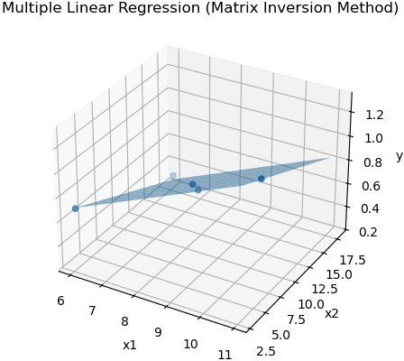

# Gradient Descent
x1 = np.array([8, 11, 9, 6, 6], dtype=float)
x2 = np.array([12, 6, 6, 3, 18], dtype=float)
y = np.array([0.6, 1.2, 1.0, 0.7, 0.3], dtype=float) m = len(y)
b0 = 0.0
b1 = 0.0
b2 = 0.0
alpha = 0.001
iterations = 10000 costs = []
for _ in range(iterations):
y_hat = b0 + b1 * x1 + b2 * x2
cost = (1 / (2 * m)) * np.sum((y_hat - y) ** 2) costs.append(cost)
db0 = (1 / m) * np.sum(y_hat - y)
db1 = (1 / m) * np.sum((y_hat - y) * x1) db2 = (1 / m) * np.sum((y_hat - y) * x2)
b0 = b0 - alpha * db0 b1 = b1 - alpha * db1 b2 = b2 - alpha * db2
print("Regression Coefficients (Gradient Descent):") print("b0 =", b0)
print("b1 =", b1)
print("b2 =", b2)
y_pred = b0 + b1 * x1 + b2 * x2 errors = y - y_pred
print("\nPredicted values:", y_pred) print("Errors:", errors)
MSE = np.mean(errors ** 2) RMSE = np.sqrt(MSE)
print("\nMean Squared Error (MSE):", MSE) print("Root Mean Squared Error (RMSE):", RMSE)
plt.figure() plt.plot(range(iterations), costs) plt.xlabel("Iterations") plt.ylabel("Cost J(b)")

plt.title("Cost vs Iterations (Gradient Descent)") plt.show()
plt.close() print()
fig = plt.figure()
ax = fig.add_subplot(111, projection='3d') ax.scatter(x1, x2, y)
x1_range = np.linspace(min(x1), max(x1), 10) x2_range = np.linspace(min(x2), max(x2), 10) x1_grid, x2_grid = np.meshgrid(x1_range, x2_range)
y_grid = b0 + b1 * x1_grid + b2 * x2_grid ax.plot_surface(x1_grid, x2_grid, y_grid, alpha=0.5)
ax.set_xlabel("x1") ax.set_ylabel("x2") ax.set_zlabel("y")
ax.set_title("Multiple Linear Regression (Gradient Descent)") plt.show()
Regression Coefficients (Gradient Descent):
b0 = 0.03707125019090349
b1 = 0.1214632026610084
b2 = -0.027884114928968393
Predicted values: [0.67416749 1.20586179 0.96293538 0.68219812
0.2639364 ]
Errors: [-0.07416749 -0.00586179 0.03706462 0.01780188 0.0360636 ]
Mean Squared Error (MSE): 0.0017052907058711954 Root Mean Squared Error (RMSE): 0.04129516564770258

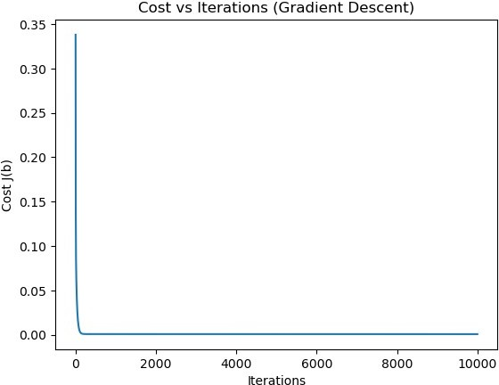

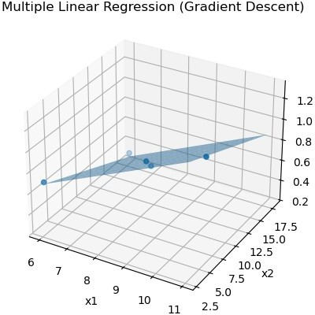
# Gradient Descent with stopping criteria
x1 = np.array([8, 11, 9, 6, 6], dtype=float)
x2 = np.array([12, 6, 6, 3, 18], dtype=float)
y = np.array([0.6, 1.2, 1.0, 0.7, 0.3], dtype=float) m = len(y)
b0 = 0.0
b1 = 0.0
b2 = 0.0
alpha = 0.001 epsilon = 1e-6
max_iterations = 10000
costs = []
prev_cost = float("inf")
for i in range(max_iterations): y_hat = b0 + b1 * x1 + b2 * x2
cost = (1 / (2 * m)) * np.sum((y_hat - y) ** 2) costs.append(cost)
if abs(prev_cost - cost) < epsilon:

print(f"Converged at iteration {i}") break
prev_cost = cost
db0 = (1 / m) * np.sum(y_hat - y)
db1 = (1 / m) * np.sum((y_hat - y) * x1) db2 = (1 / m) * np.sum((y_hat - y) * x2)
b0 -= alpha * db0 b1 -= alpha * db1 b2 -= alpha * db2
print("Regression Coefficients:") print("b0 =", b0)
print("b1 =", b1)
print("b2 =", b2)
y_pred = b0 + b1 * x1 + b2 * x2 errors = y - y_pred
MSE = np.mean(errors ** 2) RMSE = np.sqrt(MSE)
print("\nMean Squared Error (MSE):", MSE) print("Root Mean Squared Error (RMSE):", RMSE)
plt.figure() plt.plot(costs) plt.xlabel("Iterations") plt.ylabel("Cost J(b)")
plt.title("Cost vs Iterations (Gradient Descent with Stopping Criteria)")
plt.show() plt.close()
print()
fig = plt.figure()
ax = fig.add_subplot(111, projection='3d') ax.scatter(x1, x2, y)
x1_range = np.linspace(min(x1), max(x1), 10) x2_range = np.linspace(min(x2), max(x2), 10) x1_grid, x2_grid = np.meshgrid(x1_range, x2_range)
y_grid = b0 + b1 * x1_grid + b2 * x2_grid ax.plot_surface(x1_grid, x2_grid, y_grid, alpha=0.5)

ax.set_xlabel("x1") ax.set_ylabel("x2") ax.set_zlabel("y")
ax.set_title("Multiple Linear Regression (Gradient Descent)") plt.show()
Converged at iteration 241
Regression Coefficients:
b0 = 0.011889205371535552
b1 = 0.12244371443721642
b2 = -0.026264388424001948
Mean Squared Error (MSE): 0.0018908630233407612 Root Mean Squared Error (RMSE): 0.043484054817148336
